NATIONAL DEVELOPMENT COMPANY
FREEDOM OF INFORMATION (FOI) PEOPLE’S MANUAL

- PURPOSE

To guide and assist all requestors for data or information from NDC pursuant to Executive Order No. 2 on Freedom of Information.

- NDC ADDRESS AND FOI OFFICERS

- NDC is located at the:

NDC Building, 116 Tordesillas St
Salcedo Village, 1227 Makati City
Tel No. 840-48-38

- NDC’s FOI Receiving Officer (FRO) is Emily T. Cariaga, HR Officer V, Finance and Administrative Department.

- NDC’s FOI Decision Maker (FDM) is Atty. Benjamin Irineo Jude F. Rabuco III, Department Manager III, Legal Department.

- NDC’s Appeals and Review Committee is as follows:

Name | Designation
- SATURNINO H. MEJIA | Assistant General Manager  Special Projects Group
- ATTY. RHOEL Z. MABAZZA | Assistant General Manager  Corporate Support Group
- JOYCE ANNE N. ALIMON | Assistant General Manager  Funds Management Group

The NDC Appeals and Review Committee shall exercise the following functions:

- Receive, review, evaluate, and assess the appeal on the denial of the request for information;
- Determine if the appeal was filed within the period provided under EO No. 2, s. 2016
- Recommend to the Head of Agency the actions on the appeal filed by the requesting party;
- Ensure that the appeal be decided within thirty (30) working days from the filing of said appeal; and
- Implement the decision of the Head of Agency regarding the appeal

- STANDARD OPERATING INSTRUCTION (SOI)

- Submission of Request for Information and Initial Evaluation

  - All requests for FOI data from NDC must be in writing and may be submitted either personally or by registered mail.

  - Requestors must accomplish the FOI Request Form, which may be obtained from the Secretary of the Legal Department or may be downloaded at the NDC website, declaring therein the requestor’s name, contact information and purpose of the request for information.

  - The requestor must also provide a valid proof of identity including the authorization and proof of identity of the authorized representative, if the request is made through a representative.

  - Requestors must submit the duly accomplished FOI Request Form to:

Emily T. Cariaga
FOI Receiving Officer
Finance and Administrative Dept.,
National Development Company
8F NDC Building,
116 Tordesillas St.
Salcedo Village, Makati City

    - Transmittal of Request by the FRO to FDM.

      - Complete and properly accomplished FOI Requests Form shall be transmitted by the FRO to the FDM within one (1) working day from date of receipt.

      - An acknowledgment Receipt shall be given to the requestor stating therein the date on which his request shall be released by NDC which shall not be later than 15 working days from NDC’s receipt of the request, except for necessary extensions. In case of extensions, NDC shall duly inform the requestor for the needed extension which shall not be more than 20 working days.

      - Incomplete or improperly accomplished FOI Requests Forms shall be returned to the requestor for completion or amendments.

    - Approval by the FDM and Release of FOI Data

      - Information which are in NDC’s custody.

        - The FDM through the Legal Department’s Secretary, shall within 2 working days transmit the request to the specific work group which has custody of the records.

        - He shall ensure that the responsible work group shall provide the required data or give a feed back as to the status of the request within 10 working days from its date of receipt of the request.

        - Upon receipt of the data from the concerned work group, the FDM shall then transmit the requested information, through the FRO, to the requesting party within 15 working days from the date of NDC’s receipt of the request.

        - In the event that the responsible work group (s) requests for a period of extension to fully locate and provide the data required, the FDM shall instruct the FRO to draft the necessary letter to the requesting party regarding the needed extension. Extensions shall only be a maximum of 20 working days.

      - Information already available on-line or posted in NDC’s website

Should the information being requested is already posted and publicly available in NDC’s website or in other agencies’ websites, the FDM shall inform the requesting party of the said fact and provide them the website link where the information is posted.

      - Information not in NDC’s custody and/or available in other agencies.

If the requested information is not in NDC’s custody, the FDM shall immediately refer the same to the appropriate agency and accordingly inform the requesting party about the unavailability of the information in NDC and the referral of his request to the concerned agency.

- Information which shall be denied by the FDM

- Requests which are not made in writing, do not disclose the name and contact information of the requestor including such requests which do not provide any valid proof of identity of the requestor or the authorization or valid proof of identity of the requestor’s representative, if the requests is made through a representative.

- NDC may not also act upon unreasonable subsequent identical or substantially similar requests from the same requesting party and which request has already been previously granted or denied by NDC.

- Notice of denials shall be signed by the FDM and shall be transmitted within 15 working days to the requesting party. The notice shall clearly set forth the ground or grounds for denial and the circumstances on which the denial is based. Failure by NDC to act on any requests within 15 working days shall be deemed a denial on the request for access to information.

- However, in case of item (b), the FDM shall immediately or within 2 working days notify the requesting party to provide and complete the necessary data required so NDC may give due course to the request. The requesting party’s reply to the same shall be treated as a new request in which the 15- working days response period for NDC starts anew.

- Exceptions to Right of Access to Information

The following are the exceptions to the right of access to information, as recognized by the Constitution, existing laws or jurisprudence:

- Information covered by Executive privilege;

- Privileged information relating to national security, defense or international relations;

- Information concerning law enforcement and protection of public and personal safety;

- Information deemed confidential for the protection of the privacy of the persons and certain individuals such as minors, victims of crimes, or the accused;

- Information, documents or records known by reason of official capacity and are deemed as confidential, including those submitted or disclosed by entities to government agencies, tribunals, boards, or officers, in relation to the performance of their functions, or to inquiries or investigation conducted by them in the exercise of their administrative, regulatory or quasi-judicial powers;

- Prejudicial premature disclosure;

- Records of proceedings or information from proceedings which, pursuant to law or relevant rules and regulations, are treated as confidential or privileged;

- Matters considered confidential under banking and finance laws, and their amendatory laws; and

- Other exceptions to the right to information under existing laws, jurisprudence, rules and regulations.

- Appeals

- A person whose request has been denied by the FDM may file a written appeal to:

SATURNINO H. MEJIA
Chairperson
FOI Appeals Committee
National Development Company
8F NDC Building
116 Tordesillas St
Salcedo Village, Makati City

  - The written appeal must be filed by the same person making the request for information within fifteen (15) working days from notice of denial or from the lapse of the relevant period to respond to the request.

  - The appeal shall be decided by the Appeals Committee and shall inform the appellant within thirty (30) days from the date of filing of the appeal. Failure to act on the appeal within said period shall be deemed as a denial of the appeal.

  - The requesting party may file an appropriate case in the proper courts upon exhaustion of administrative remedies.

7. “No Wrong Door Policy”

In compliance with FOI-MC No. 21-05 or the Guidelines on the Referral of Requested Information, Official Record/s and Public Record/s to the Appropriate Government Agency, otherwise known as the “No Wrong Door Policy for FOI,” the NDC will not deny FOI requests for information and/or records not under its possession but instead refer the request to the appropriate government agency which is the proper repository or custodian of the requested information or records, or have control over the said information or records (See Annex F).

- FEES

NDC shall charge five pesos (P5.00) per page representing the actual reproduction costs in providing the information to the requesting party excluding the actual costs of courier services in case the request for data may be requested by the party to be mailed to them.

- FLOWCHARTS (see next page)

Incomplete or improperly accomplished FOR Request Form shall be returned to the Requesting party for completion or amendment
Release Information/Records RECEIVING OFFICER11
FOI RECEIVING OFFICER
30 working days
Appeals CommitteeR11
AppealR11
15 working days
FDM decides either to approve or deny the request. He shall immediately notify the FRO who shall prepare the response
Inform of DenialFFICER11
DENIAL
1111
FDM should inform FRO. FRO shall inform Requesting Party for extension, which shall not be more than 20 working days
APPROVE
1111
Making Decision
If an extension is required
Preparing records for access
0
Transmittal of Request
Receipt of Request for Information / Records RECEIVING OFFICER
FOI RECEIVING OFFICER
1
FOI DECISION MAKER
FOI REQUEST
(in writing)
REQUESTING
PARTY
0

Annex A
NATIONAL DEVELOPMENT COMPANY
8F NDC Building, 116 Tordesillas St
Salcedo Village, Makati City
NATIONAL DEVELOPMENT COMPANY
Tel No. 840-48-38 local 273

FOI REQUEST FORM and ACKNOWLEDGMENT RECEIPT

TITLE OF DOCUMENT REQUESTED_______________________________________________
DATE OF DOCUMENT ________________________________________________________
PURPOSE:

_________________________________________________________________________________
________________________________________________________________________________
________________________________________________________________________________
________________________________________________________________________________
________________________________________________________________________________
________________________________________________________________________________
________________________________________________________________________________

Name of Requestor _______________________________ Contact No. _________________
Signature _______________________________ Date_______________________
How would you like to receive the Info?: Proof of Identity ____________________________
________1. Email
________2. Pick-Up
________3. Registered Mail. Postal Address ___________________________________________
________4. Courier. ________________________________________________________

============================================================================

NATIONAL DEVELOPMENT COMPANY
8F NDC Building, 116 Tordesillas St
Salcedo Village, Makati City
Tel No. 840-48-38 local 273

ACKNOWLEDGEMENT RECEIPT

Date submitted the request________________________________________________________

Date of Release of the Document/Response _________________________________________

____________________________________________
FOI Receiving Officer ( Name and Signature)

Annex B

NATIONAL DEVELOPMENT COMPANY
8F NDC Building, 116 Tordesillas St
Salcedo Village, Makati City
Tel No. 840-48-38 local 273

FOI RESPONSE TEMPLATE

Date :______________

Dear _______________:

Greetings!

Thank you for your request dated (insert date) under Executive Order No. 2, s. 2016 on Freedom of Information in the Executive Branch.

Your Request:

You asked for (quote requests exactly)

Response to your Request:

Your FO request is approved. Enclosed is a copy of the information you requested.

Thank you.

Respectfully,

_____________________
FOI Decision Maker

Annex C

NATIONAL DEVELOPMENT COMPANY
8F NDC Building, 116 Tordesillas St
Salcedo Village, Makati City
Tel No. 840-48-38 local 273

FOI RESPONSE TEMPLATE- DOCUMENT AVAILABLE ONLINE

Date :______________

Dear _______________:

Greetings!

Thank you for your request dated (insert date) under Executive Order No. 2, s. 2016 on Freedom of Information in the Executive Branch.

Your Request:

You asked for (quote requests exactly)

Response to your Request:

Some/Most/All of the information you have requested is already available online from (add details of where the information can be obtains e.g. data.gov.ph. foi.gov.ph, or wwww.ndc.gov.ph)

Your Right to Request a Review:

If you are unhappy with this response to your FOI request, you may ask us to carry out an internal review of the response in writing to: Review and Appeals Committee c/o Office of the AGM of Special Projects Group, 8F NDC Building, 116 Tordesillas St., Salcedo Village, Makati City. Your review request should explain why you are dissatisfied with this response, and should be made within 15 calendar days from your date of receipt of this letter. NDC shall complete the review and respond to you within 30 days from out receipt of your appeal.

If you will not be satisfied with the results of the review, you then have the right to the appeal to the Office of the President under Administrative Order. No. 22, s. 2011.

Thank you.

Respectfully,

_____________________
FOI Decision Maker

Annex D

NATIONAL DEVELOPMENT COMPANY
8F NDC Building, 116 Tordesillas St
Salcedo Village, Makati City
Tel No. 840-48-38 local 273

FOI RESPONSE TEMPLATE- DOCUMENT NOT AVAILABLE

Date :______________

Dear _______________:

Greetings!

Thank you for your request dated (insert date) under Executive Order No. 2, s. 2016 on Freedom of Information in the Executive Branch.

Your Request:

You asked for (quote requests exactly)

Response to your Request:

While our aim is to provide information whenever possible, in this instance NDC does not have the information your requested. However, you may wish to contact (insert appropriate agency). We have accordingly forwarded them your request.

Your Right to Request a Review:

If you are unhappy with this response to your FOI request, you may ask us to carry out an internal review of the response in writing to: Review and Appeals Committee c/o Office of the AGM of Special Projects Group, 8F NDC Building, 116 Tordesillas St., Salcedo Village, Makati City. Your review request should explain why you are dissatisfied with this response, and should be made within 15 calendar days from your date of receipt of this letter. NDC shall complete the review and respond to you within 30 days from out receipt of your appeal.

If you will not be satisfied with the results of the review, you then have the right to the appeal to the Office of the President under Administrative Order. No. 22, s. 2011.

Thank you.

Respectfully,

_____________________
FOI Decision Maker

Annex E

NATIONAL DEVELOPMENT COMPANY
8F NDC Building, 116 Tordesillas St
Salcedo Village, Makati City
Tel No. 840-48-38 local 273

FOI RESPONSE TEMPLATE- UNDER EXPECTIONS

Date :______________

Dear _______________:

Greetings!

Thank you for your request dated (insert date) under Executive Order No. 2, s. 2016 on Freedom of Information in the Executive Branch.

Your Request:

You asked for (quote requests exactly)

Response to your Request:

While our aim is to provide information whenever possible, in this instance we are unable to provide the information your have requested because an exception under sections (insert specific numbers) of the List of exceptions applies to that information.

Your Right to Request a Review:

If you are unhappy with this response to your FOI request, you may ask us to carry out an internal review of the response in writing to: Review and Appeals Committee c/o Office of the AGM of Special Projects Group, 8F NDC Building, 116 Tordesillas St., Salcedo Village, Makati City. Your review request should explain why you are dissatisfied with this response, and should be made within 15 calendar days from your date of receipt of this letter. NDC shall complete the review and respond to you within 30 days from out receipt of your appeal.

If you will not be satisfied with the results of the review, you then have the right to the appeal to the Office of the President under Administrative Order. No. 22, s. 2011.

Thank you.

Respectfully,

_____________________
FOI Decision Maker

Annex F

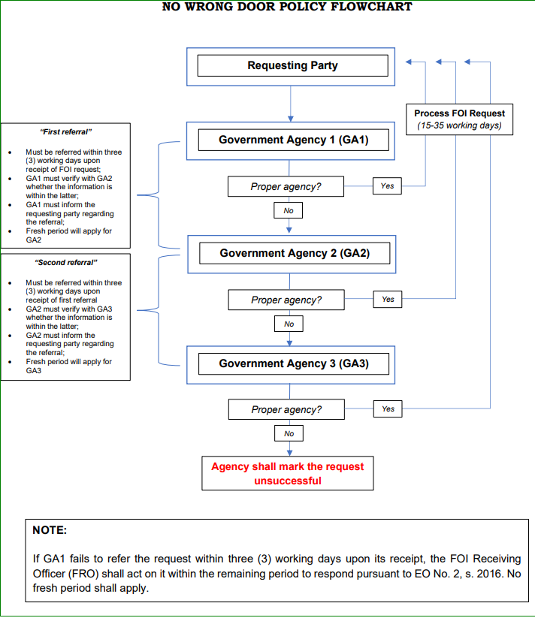

Source: FOI-MC No. 21-05

